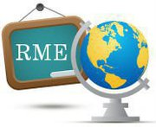
Restoring the Meaning of Education

Learn how to change the school system!

E-mail: rme2011@yahoo.com
Website: http://restoringthemeaningofeducation.weebly.com/index.html

